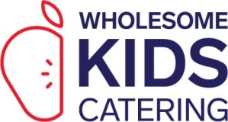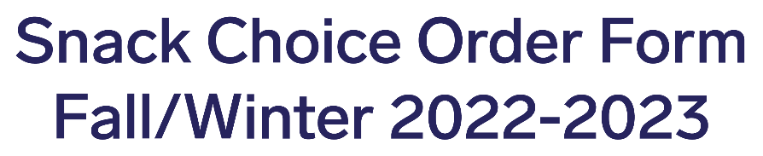
Please select your snack choices below by circling or highlighting the choice boxes below.
*Please note that Standard Snack and Standard Snack Plus are priced differently. Please contact Customer Care with any pricing inquiries. **If we do not receive a choice form, your selections for days and snack type will remain from the previous seasonal menu. These snacks are in effect starting Monday, October 31, 2022.
Email form to: customer.care@wholesomekids.ca For all inquiries, please contact us at 905-752-8115 X356. Centre/School Name:
 |  | Monday |  | Tuesday |  | Wednesday |  | Thursday |  | Friday
 |  | Standard | Standard + | Standard | Standard + | Standard | Standard + | Standard | Standard + | Standard | Standard +
WEEK 1 | AM | Multi Grain Cheerios, Milk | Multi Grain Cheerios, Milk, Fresh Fruit | Banana Oatmeal Bar | Banana Oatmeal Bar, Fresh Fruit | Whole Wheat English Muffin, Apple Butter | Whole Wheat English Muffin, Apple Butter, Fresh Fruit | Organic Whole Wheat Banana Muffin | Organic Whole Wheat Banana Muffin, Applesauce | Whole Grain Shreddies Cereal, Milk | Whole Grain Shreddies Cereal, Milk, Fresh Fruit
 | PM | Organic Oatmeal Cranberry Cookie, Fresh Fruit | Organic Oatmeal Cranberry Cookie, Fresh Fruit, Vanilla Yogurt | Spice Snap Biscuits, Grape Tomatoes | Spice Snap Biscuits, Grape Tomatoes, Edamame | Whole Wheat Mini Pita, Hummus | Whole Wheat Mini Pita, Hummus, Baby Carrots | Whole Wheat Crackers, Cheddar Cheese Cubes | Whole Wheat Crackers, Cheddar Cheese Cubes, Cucumbers | Whole Wheat Oatmeal Raisin Loaf, Fresh Fruit | Whole Wheat Oatmeal Raisin Loaf, Fresh Fruit, Hardboiled Egg
WEEK 2 | AM | Corn Flakes Cereal, Milk | Corn Flakes Cereal, Milk, Fresh Fruit | Whole Wheat Mini Bagel, Apple Butter | Whole Wheat Mini Bagel, Apple Butter, Fresh Fruit | Strawberry Yogurt, Whole Grain Granola | Strawberry Yogurt, Whole Grain Granola, Fresh Fruit | Whole Wheat Chunky Apple Muffin | Whole Wheat Chunky Apple Muffin, Fresh Fruit | Rice Krispies Cereal, Milk | Rice Krispies Cereal, Milk, Fresh Fruit
 | PM | Organic Spelt Mini Ginger Snaps, Baby Carrots | Organic Spelt Mini Ginger Snaps, Baby Carrots, Hummus | Banana Oatmeal Bar, Fresh Fruit | Banana Oatmeal Bar, Fresh Fruit, Edamame | Whole Wheat Bread Sticks, Guacamole | Whole Wheat Bread Sticks, Guacamole, Cheese Cubes | Oatmeal Cookie, Applesauce | Oatmeal Cookie, Applesauce, Hardboiled Egg | Whole Wheat Blueberry Bran Loaf, Baby Carrots | Whole Wheat Blueberry Bran Loaf, Baby Carrots, Vanilla Yogurt
WEEK 3 | AM | Multi Grain Cheerios, Milk | Multi Grain Cheerios, Milk, Fresh Fruit | Mini Strawberry Crackers | Mini Strawberry Crackers, Applesauce | Whole Grain Shreddies Cereal, Milk | Whole Grain Shreddies Cereal, Milk, Fresh Fruit | Whole Wheat Pancake, Apple Butter | Whole Wheat Pancake, Apple Butter, Fresh Fruit | Organic Whole Wheat Lemon Coconut Muffin | Organic Whole Wheat Lemon Coconut Muffin, Fresh Fruit
 | PM | Organic Spelt Mini Lemon Snaps, Fresh Fruit | Organic Spelt Mini Lemon Snaps, Fresh Fruit, Cheese Curds | Spice Snap Biscuits, Cucumber Slices | Spice Snap Biscuits, Cucumber Slices, Hummus | Whole Wheat Lemon Cranberry Loaf, Fresh Fruit | Whole Wheat Lemon Cranberry Loaf,  Fresh Fruits, Hardboiled Egg | Banana Oatmeal Cookie, Baby Carrots | Banana Oatmeal Cookie, Baby Carrots, Vanilla Yogurt | Artisan Bread, Bruschetta | Artisan Bread, Bruschetta, Edamame
WEEK 4 | AM | Corn Flakes Cereal, Milk | Corn Flakes Cereal, Milk, Fresh Fruit | Peach Yogurt, Whole Grain Granola | Peach Yogurt, Whole Grain Granola, Fresh Fruit | Banana Oat Bite | Banana Oat Bite, Fresh Fruit | Organic Whole Wheat Carrot Zucchini Muffin | Organic Whole Wheat Carrot Zucchini Muffin, Fresh Fruit | Rice Krispies Cereal, Milk | Rice Krispies Cereal, Milk, Fresh Fruit
 | PM | Wheat Crackers, Cheese Curds | Wheat Crackers, Cheese Curds, Fresh Fruit | Whole Wheat Mini Pita, Grape Tomatoes | Whole Wheat Mini Pita, Grape Tomatoes, Cheddar Cheese Slice | Cinnamon Scone, Fresh Fruit | Cinnamon Scone, Fresh Fruit, Vanilla Yogurt | Whole Wheat Mini Bagel, Cheddar Cheese Cubes | Whole Wheat Mini Bagel, Cheddar Cheese Cubes, Cucumber Slices | Whole Wheat Oat and Date Loaf, Fresh Fruit | Whole Wheat Oat and Date Loaf, Fresh Fruit, Edamame
